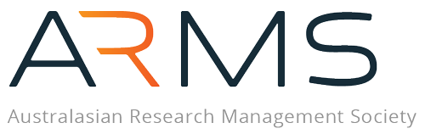
CALL (EOI) FOR THE ESTABLISHMENT OF AN INDIGENOUS ENGAGEMENT WORKING GROUP – TEMPLATE
The Indigenous Engagement Working Group will bring together both First Nations and Indigenous members, and non-Indigenous members, who are committed to advancing this important strategic priority.
We recognise that people bring different knowledge, experiences, and strengths. For Indigenous members, this may include cultural knowledge, lived experience, or values-based ways of working. For non-Indigenous members, this may include allyship, partnership experience, or skills in research management and implementation.
Your contribution will help ensure that Indigenous voices and perspectives are central to shaping the future of research management.
Please submit your completed EOI to ARMSCOO@researchmanagement.org.au by Friday, 7 November 2025.

SECTION 1: ABOUT YOU:
Name: (Title/Given Name/Surname):
Current Institution/Organisation:
Email Address:
Preferred Contact Phone Number:
Length of ARMS Membership:
Which of the following best describes your cultural background or ethnicity? (select by x all that apply)
Aboriginal and/or Torres Strait Islander
Māori
Pacific Islander
Australian of European descent
Asian
African
Middle Eastern
Other (please specify
Prefer not to say

SECTION 2: Please tell us in 300 words why you would like to join the Indigenous Engagement Working Group

SECTION 3: What perspectives, experiences, or approaches would you like to bring into this Working Group? – 300 word limit - (Please note that if you identify as First Nations and/or Indigenous, you may wish to share cultural knowledge, values, or lived experience. If you are non-Indigenous, you may wish to share experience in partnership building, allyship, or supporting Indigenous research practices.)

SECTION 4: Please share any previous experience you have that could support the purpose of this Working Group.
(For example: working in research management, community engagement, partnerships, policy, or advocacy)
SECTION 5: Which area(s) of the Working Group’s purpose are you most interested in contributing to?
☐ Embedding Indigenous practices and perspectives in research management
☐ Identifying practical, measurable outcomes
☐ Developing actions, partnerships, and resources
☐ Ensuring Indigenous voices are central

SECTION 6: Direct Report Verification I confirm that the nominee is my direct report and fully endorse their participation in the working group.
Name of Direct Report | Signature | Date

