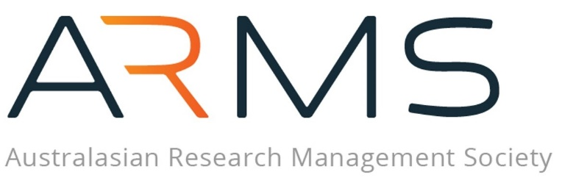

FELLOWS OF ARMS – 2026 CALL FOR NOMINATIONS

NOMINATION GUIDELINES

Nominations must be received by 5 pm AEST, Monday the 27th of July 2026 ARMSMembership@researchmanagement.org.au

Late nominations will not be accepted.
Fellows of ARMS are distinguished Research Management Professionals who have made significant and lasting contributions to the research management profession across Australasia. Whether through practice, mentorship, training, or advocacy, these individuals embody excellence across the profession.
As part of the Society’s commitment of being the foremost advocate for research management in Australasia, recipients of this prestigious honour will receive the title Fellow of ARMS. This distinction acknowledges their ongoing contributions to this vision, demonstrated through active involvement in the ARMS community, sharing of expertise, promotion of best practices, and provision of insights that go beyond the expectations of standard membership.
At the time of nomination, candidates must be current financial members of ARMS and must be nominated by another financial member.

ELIGIBILITY CRITERIA
To qualify as a Fellow of ARMS, applicants must:
- Be a current financial member of ARMS, with at least five years of ARMS membership.
- Demonstrate alignment with ARMS’ mission, goals, and strategic direction through their contributions.
- Provide evidence of substantial and enduring contributions to research management in Australasia.
- Show how they will continue to offer visionary leadership in the profession.
Special Note:
Recipients of the Janet Dibb-Leigh Award for Distinguished Service to Research Management automatically attain the Fellow of ARMS status and do not need to apply.

INELIGIBILITY
Current ARMS Board members are ineligible for nomination during their tenure. Nominations can only be submitted once they have officially stepped down.

RESPONSIBLITIES OF FELLOWS
Fellows of ARMS are expected to remain active participants in the research management community, fostering the advancement of the profession of research management, sharing knowledge and supporting ARMS to deliver on its strategy.

ASSESSMENT PANEL
All nominations will be evaluated by a sub-committee constituted by the Board, which will assess candidates against the eligibility criteria.

Successful candidates will be formally recognised during the Award Ceremony at the ARMS Annual Conference. Each Fellow will receive a plaque and a lapel pin and will be acknowledged on the ARMS website and the Report to Members.

APPLICATION PROCESS
To submit a nomination:
- Both nominee and nominator must be current financial members of ARMS.
- Nominations must be submitted by 5 PM AEST, Monday, 27th July 2026 to ARMSMembership@researchmanagement.org.au .
- Late submissions will not be accepted.

REQUIRED DOCUMENTATION
A complete nomination includes:
- A three-page statement outlining how the nominee meets the eligibility criteria, including key achievements (refer to Section 3 of the application form).
- A 100-word statement and high-resolution photo for promotional purposes (refer to Section 4 of the application form).
- Supporting statements from two referees (maximum one page each, refer to Section 5 of the application form).
This recognition is a testament to leadership and dedication in research management. Fellows of ARMS join a distinguished group committed to shaping the future of the profession.

KEY TIMELINES
Please observe key dates for this Award, described below:
Date | Description | Additional Information
Friday, 19 June 2026 | Call for Fellows of ARMS | Notification to be disseminated to all ARMS Members.
Monday, 27TH of July 2026 | Closing date for nominations | Completed nomination forms must be submitted to the ARMS Administration Officer – ARMSMembership@researchmanagement.org.au by cob 5 PM AEST.  Late nominations will not be accepted.
29 July – 7 August 2026 | Assessment of all nominations by a sub-committee constituted by the ARMS Board. | The ARMS Board reserves the right not to make an Award if no nominations are received which sufficiently meet the above the selection criteria.
Thursday, 10 September 2026 | Fellows of ARMS to be announced at the Award Ceremony at the ARMS Annual Conference. | ARMS President to announce the Fellows at this scheduled event.
September 2026 | Award announcement including highlights in e-newsletter, UP-IN-ARMS.

Research Management Professionals are individuals who provide strategic, management, technical, administrative, or clerical assistance to support the research endeavour.

