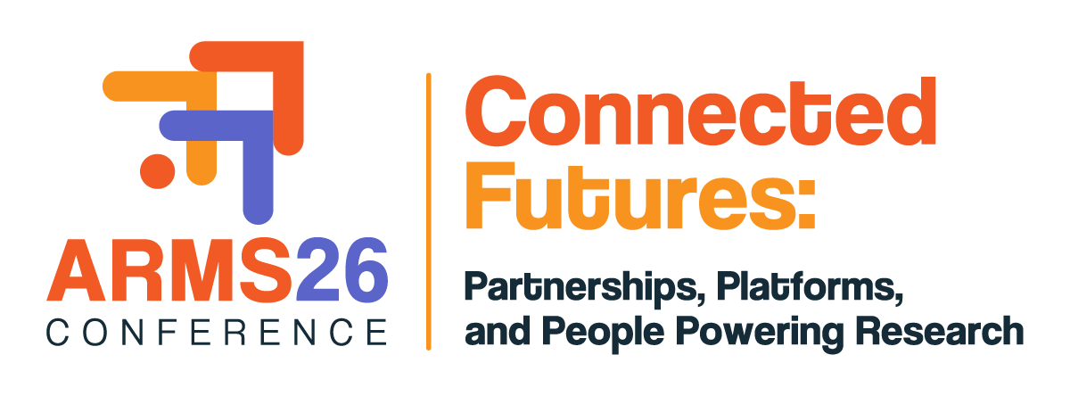

APPLICATION FORM
FOR 2026 PERTH CONFERENCE GRANT

INSTRUCTIONS:
- Complete this Application Form.
- Attach your organisation’s letter of support OR your self-employed statement.
- Email the Application Form and support letter or self-employed statement, combined into a single pdf document, to ARMSmembership@researchmanagement.org.au by no later than 5 PM AEST, Friday the 1 May 2026. Please note that late or incomplete applications will not be accepted.

PERSONAL DETAILS:
Your Name
Your Chapter
Your Position
Your Organisation
Phone |  | Email

ELIGIBILITY CRITERIA:
I am a financial member of ARMS (as an individual or part of a corporate membership) | yes no
Evidence of support:
I have attached a letter of support from my employer OR* | yes no
I am self-employed and have attached a supporting statement* | yes no
I have not been previously received an ARMS Chapter Travel Award or equivalent in the past five years. | yes no

*Supporting statement must also include the level of financial assistance to be provided by the employer or the individual to support their attendance to the 2026 Perth conference. The letter must also describe how attending the ARMS Perth conference is relevant to the applicant’s current role.

ASSESSMENT CRITERIA:
Your application should address the following criteria, up to a maximum of three (3) pages in total.

- Professional Experience and Career History: Summarise your roles, key responsibilities, and any significant challenges in the field of research management over the past five years.

- Conference Contribution and Knowledge Sharing: Identify the conference theme you will engage with (this need not involve a presentation) and explain how you plan to apply insights from the conference within your member institution.

- Career Advancement: Outline how attending the conference will benefit your professional development and support your career trajectory.

- Budget Justification: Provide justification on how any remaining costs associated with attending the conference will be covered. Applicants to be reminded that this year’s award provides support for a non-transferrable complimentary conference registration only.

