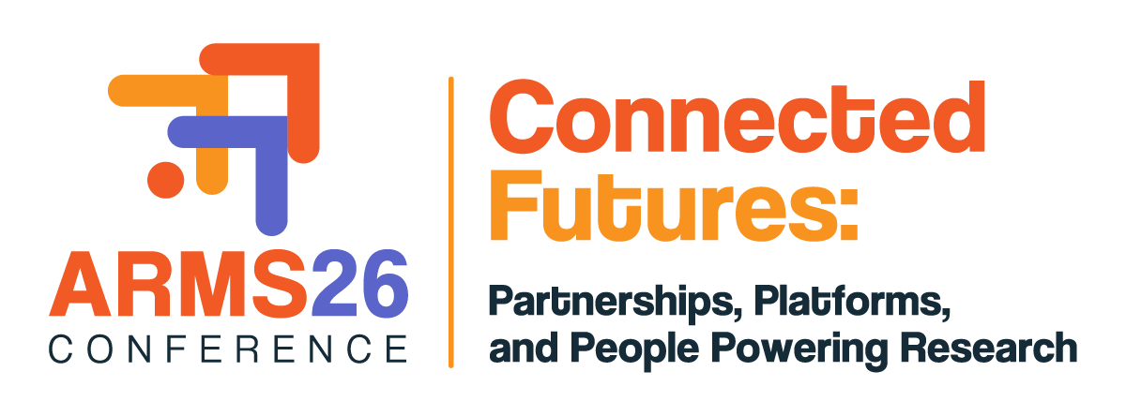

INDIGENOUS/First nations Perth conference GRANT 2026
PREAMBLE:
ARMS is dedicated to empowering its members to excel in research management while creating a vibrant, interconnected professional community. This grant reflects our deep commitment to supporting Indigenous Research Management Professionals by providing them with invaluable opportunities to connect and engage with the broader ARMS community. Their active participation not only enriches their own professional journeys but also plays an important role in fostering an inclusive environment that benefits all members.

The annual conference remains our flagship event, creating a unique space for networking, professional growth, and meaningful connections across the diverse fields of research and management.

PURPOSE OF THE INDIGENOUS/FIRST NATIONS PERTH CONFERENCE GRANT 2026:
The grant offers financial assistance to eligible ARMS members to attend the Perth Conference, scheduled from 9-11 September. Applicants must demonstrate how their attendance supports the Society's mission and aligns with the ARMS 2030 Strategic Priorities.
Each eligible applicant will be required to specify the level of support being requested (including a justification for support) and to demonstrate how any financial shortfalls in attending the conference are likely to be covered.
While it is strongly encouraged that Awardees present at the conference either as a lead or co-author, it is not essential under this grant. The recipient will however need to demonstrate relevant professional development benefits to a broader ARMS community from attending the ARMS Perth Conference.

- Applications are to be submitted using the online application form - click here
- Applications are due cob – 5 PM AEST 1 May 2026
- Applicants should discuss this opportunity with their supervisor before applying.

WHO IS ELIGIBLE?
To be considered under this program, an applicant must:

- Be an Indigenous/First Nations Research Management Professional or identify as an Indigenous/First Nations person in the Australasian context.
- Be a current financial member of ARMS at the time of the application, and for the duration of the grant (either as an individual or part of a corporate/small corporate membership).
- Demonstrate that your organisation supports your attendance at the ARMS Perth Conference and will be prepared to meet costs not covered under the grant.

WHO IS NOT ELIGIBLE?
- Members of the ARMS Board.
- If an awardee for the Indigenous/First Nations Perth Conference Grant 2026 has requested funding from other currently promoted ARMS Awards, examples include but not limited to the 2026 Perth Conference Grant or the International Research Management Travel Grant, they will only be eligible to receive one award of their choosing.

WHAT FUNDING IS AVAILABLE?
The Society may offer up to three (3) grants of up to $AUD2,500 per awardee.

Please refer to grant conditions below.

The grant can be used to offset some of the costs associated with attending the Perth Conference including registration, accommodation, flights and transfers.

how will applications be assessed?
Your application should address each of the following essential criteria:

- Professional Experience and Career History: Summarise your roles, key responsibilities, and any significant challenges in the field of research management over the past five years.

- Conference Contribution and Knowledge Sharing: Identify the conference theme you will engage with (this need not involve a presentation) and explain how you plan to apply insights from the conference within your member institution.

- Career Advancement: Outline how attending the conference will benefit your professional development and support your career trajectory.

- Budget Justification: Provide a brief explanation of the requested support amount, including details on covering additional costs not covered by the travel grant.

Applications will be reviewed by an Assessment Panel constituted by the ARMS Board.
The ARMS Executive office will notify all applicants via email stating the outcome of their application.
While there will be no appeals process, unsuccessful applicants may seek feedback upon request.
GRANT CONDITIONS:
The grant is to be used to offset the cost of attending the conference, which may include the registration fee, discounted, economy-class airfare, accommodation etc. Successful awardees are expected to travel in compliance with ARMS’ Travel Policy. Expenses incurred by the awardee are to be reconciled with receipts and a reimbursement form or invoice submitted to the ARMS Executive Office for reimbursement of expenses.

In the unlikely event that the awardee is unable to travel, all funds must be returned to ARMS.

Grants are not transferable to another person.

At the conference, Awardees may be requested to participate in promotional activities.

Awardees will be required to provide a one-page post conference report 6 weeks after the conference. This information will be used for promotional purposes, and the report is to be submitted to the ARMS Executive Office.

LETTER OF SUPPORT
Evidence of your support should be provided through a Letter of Support or Self-Employed Statement as follows:

If you are an employee, your application must be accompanied by a formal letter of support from the Line Manager or supervisor in your organisation. At a minimum, the letter should:
- Confirm that the organisation supports your attendance at the conference;
- Confirm that the organisation will meet the costs not covered by the Grant to attend the conference; and
- Describe how attending the ARMS Perth conference is relevant to your current role and responsibilities in the organisation and how it aligns with your career plan.
If you are self-employed, your application must be accompanied by a one-page statement describing your business and how it contributes to the Australasian research management sector.

KEY DATES
Date | Description
Thursday, 19 March 2026 | Call for Applications.
Friday, 1 May 2026 | Closing date for Applications – COB 5PM AEST - Applications to be submitted online – click here to commence the application.
5-15 May 2026 | Applications to be distributed to the Assessment Panel.
15 May – 29 May 2026 | The Assessment Panel will review applications, finalise recommendations, and submit those recommendations to the ARMS Board for consideration and endorsement.
By Friday, 5 June 2026 | ARMS Board to consider and endorse recommendations by the Assessment Panel.
By Friday, 12 June 2026 | Once all recommendations have been endorsed by the ARMS Board, successful applicants will be notified of their outcome.  Unsuccessful applicants will be advised once all awardees have accepted their offer.
By Friday, 19 June 2026 | Successful applicants are advised to confirm acceptance of their grant.
Thursday, 25 June 2026 | Early Bird registrations close.
9-11 September 2026 | ARMS Perth Conference
Friday, 30 October 2026 | Successful awardees to provide a one-page report on their learning outcomes from the conference to the ARMS Executive Office – ARMSMembership@researchmanagement.org.au

